ASSIGNMENT – 7

1. Code Execution:

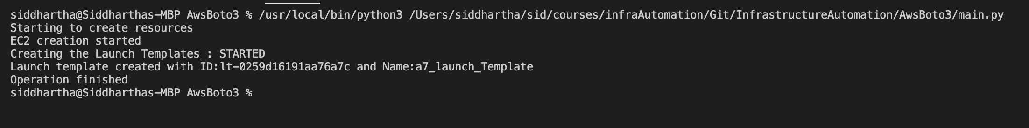

The code execution happens in the following way

1. A class Assignment7 is created which consists of the APIs for pushing the file to git, creating launch template, and creating auto scaling group.
2. Git actions are performed using bash commands through python interface.
3. Auto scale groups are created by calling the **create_ec2_auto_scaling_group** which calls the method **create_ec2_launch_template** which creates the required launch template for auto scale resource.
4. **create_ec2_launch_template** requires 'ImageId’, ‘InstanceType’, 'KeyName, 'UserData', 'SecurityGroupIds'
5. UserData is provided in base64 format. The input for the UserData is stored in the file userdata64. The exact commands that are encoded in the userdata64 file is present in the file userdata.sh. UserData is used to pass commands that are executed while the instances are booting for configuring the initial EC2 instance setup.
6. Link to HTML file : https://github.com/siddhartha12/InfrastructureAutomation/tree/main/AwsBoto3

**[Screenshots]**

1. Launch Template

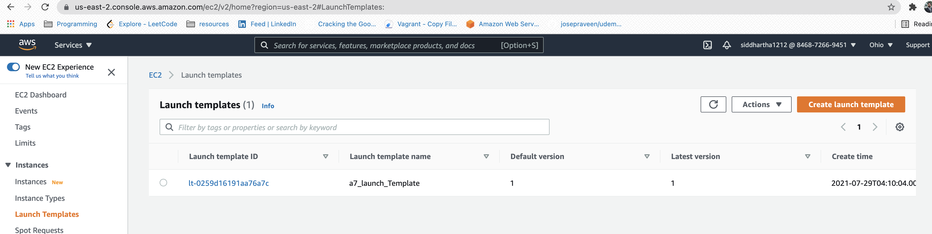

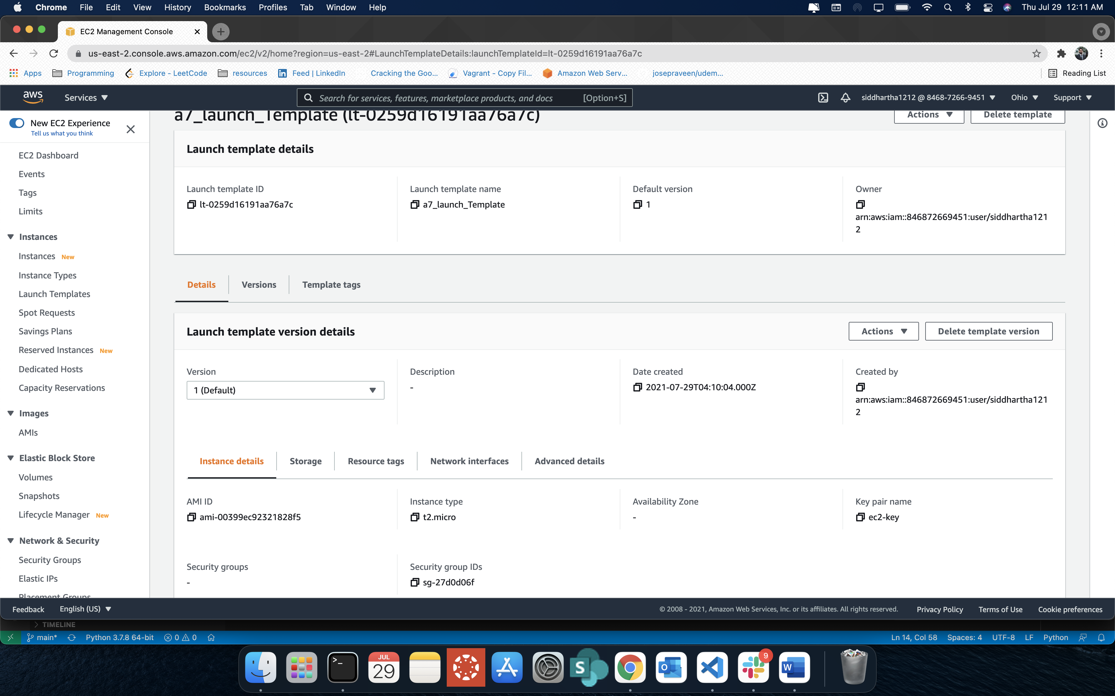

1. Auto Scaling Group

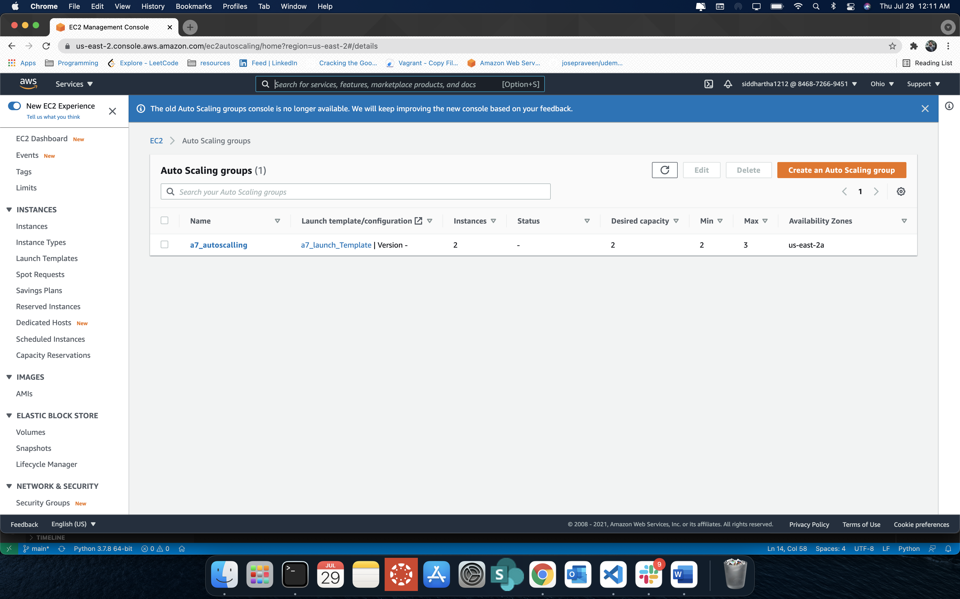

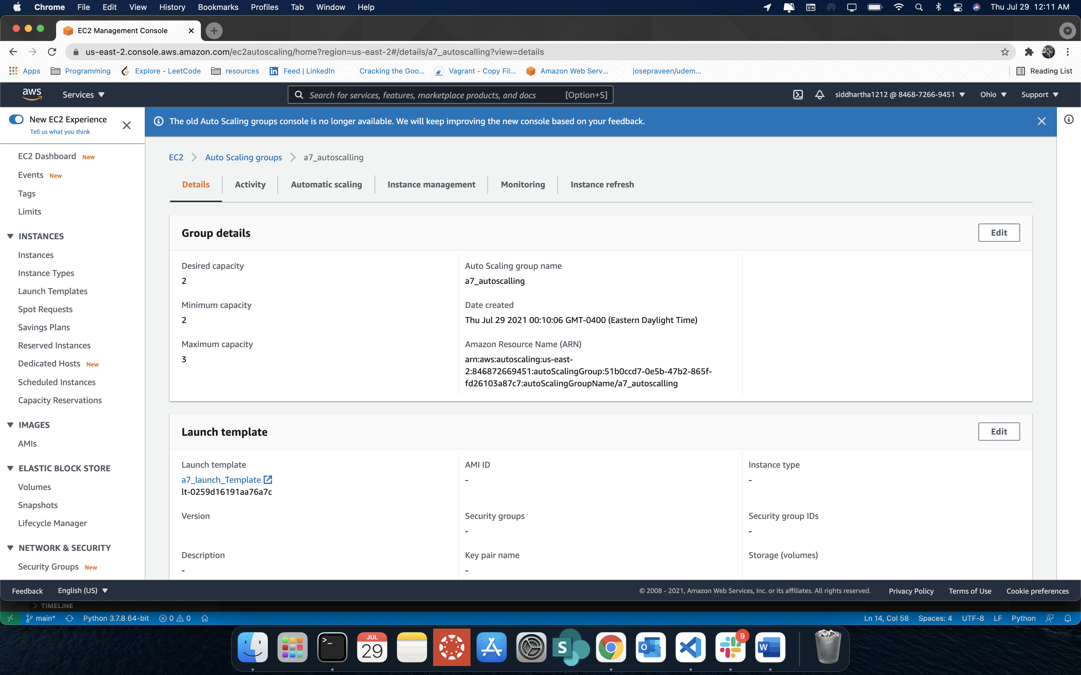

1. Instances

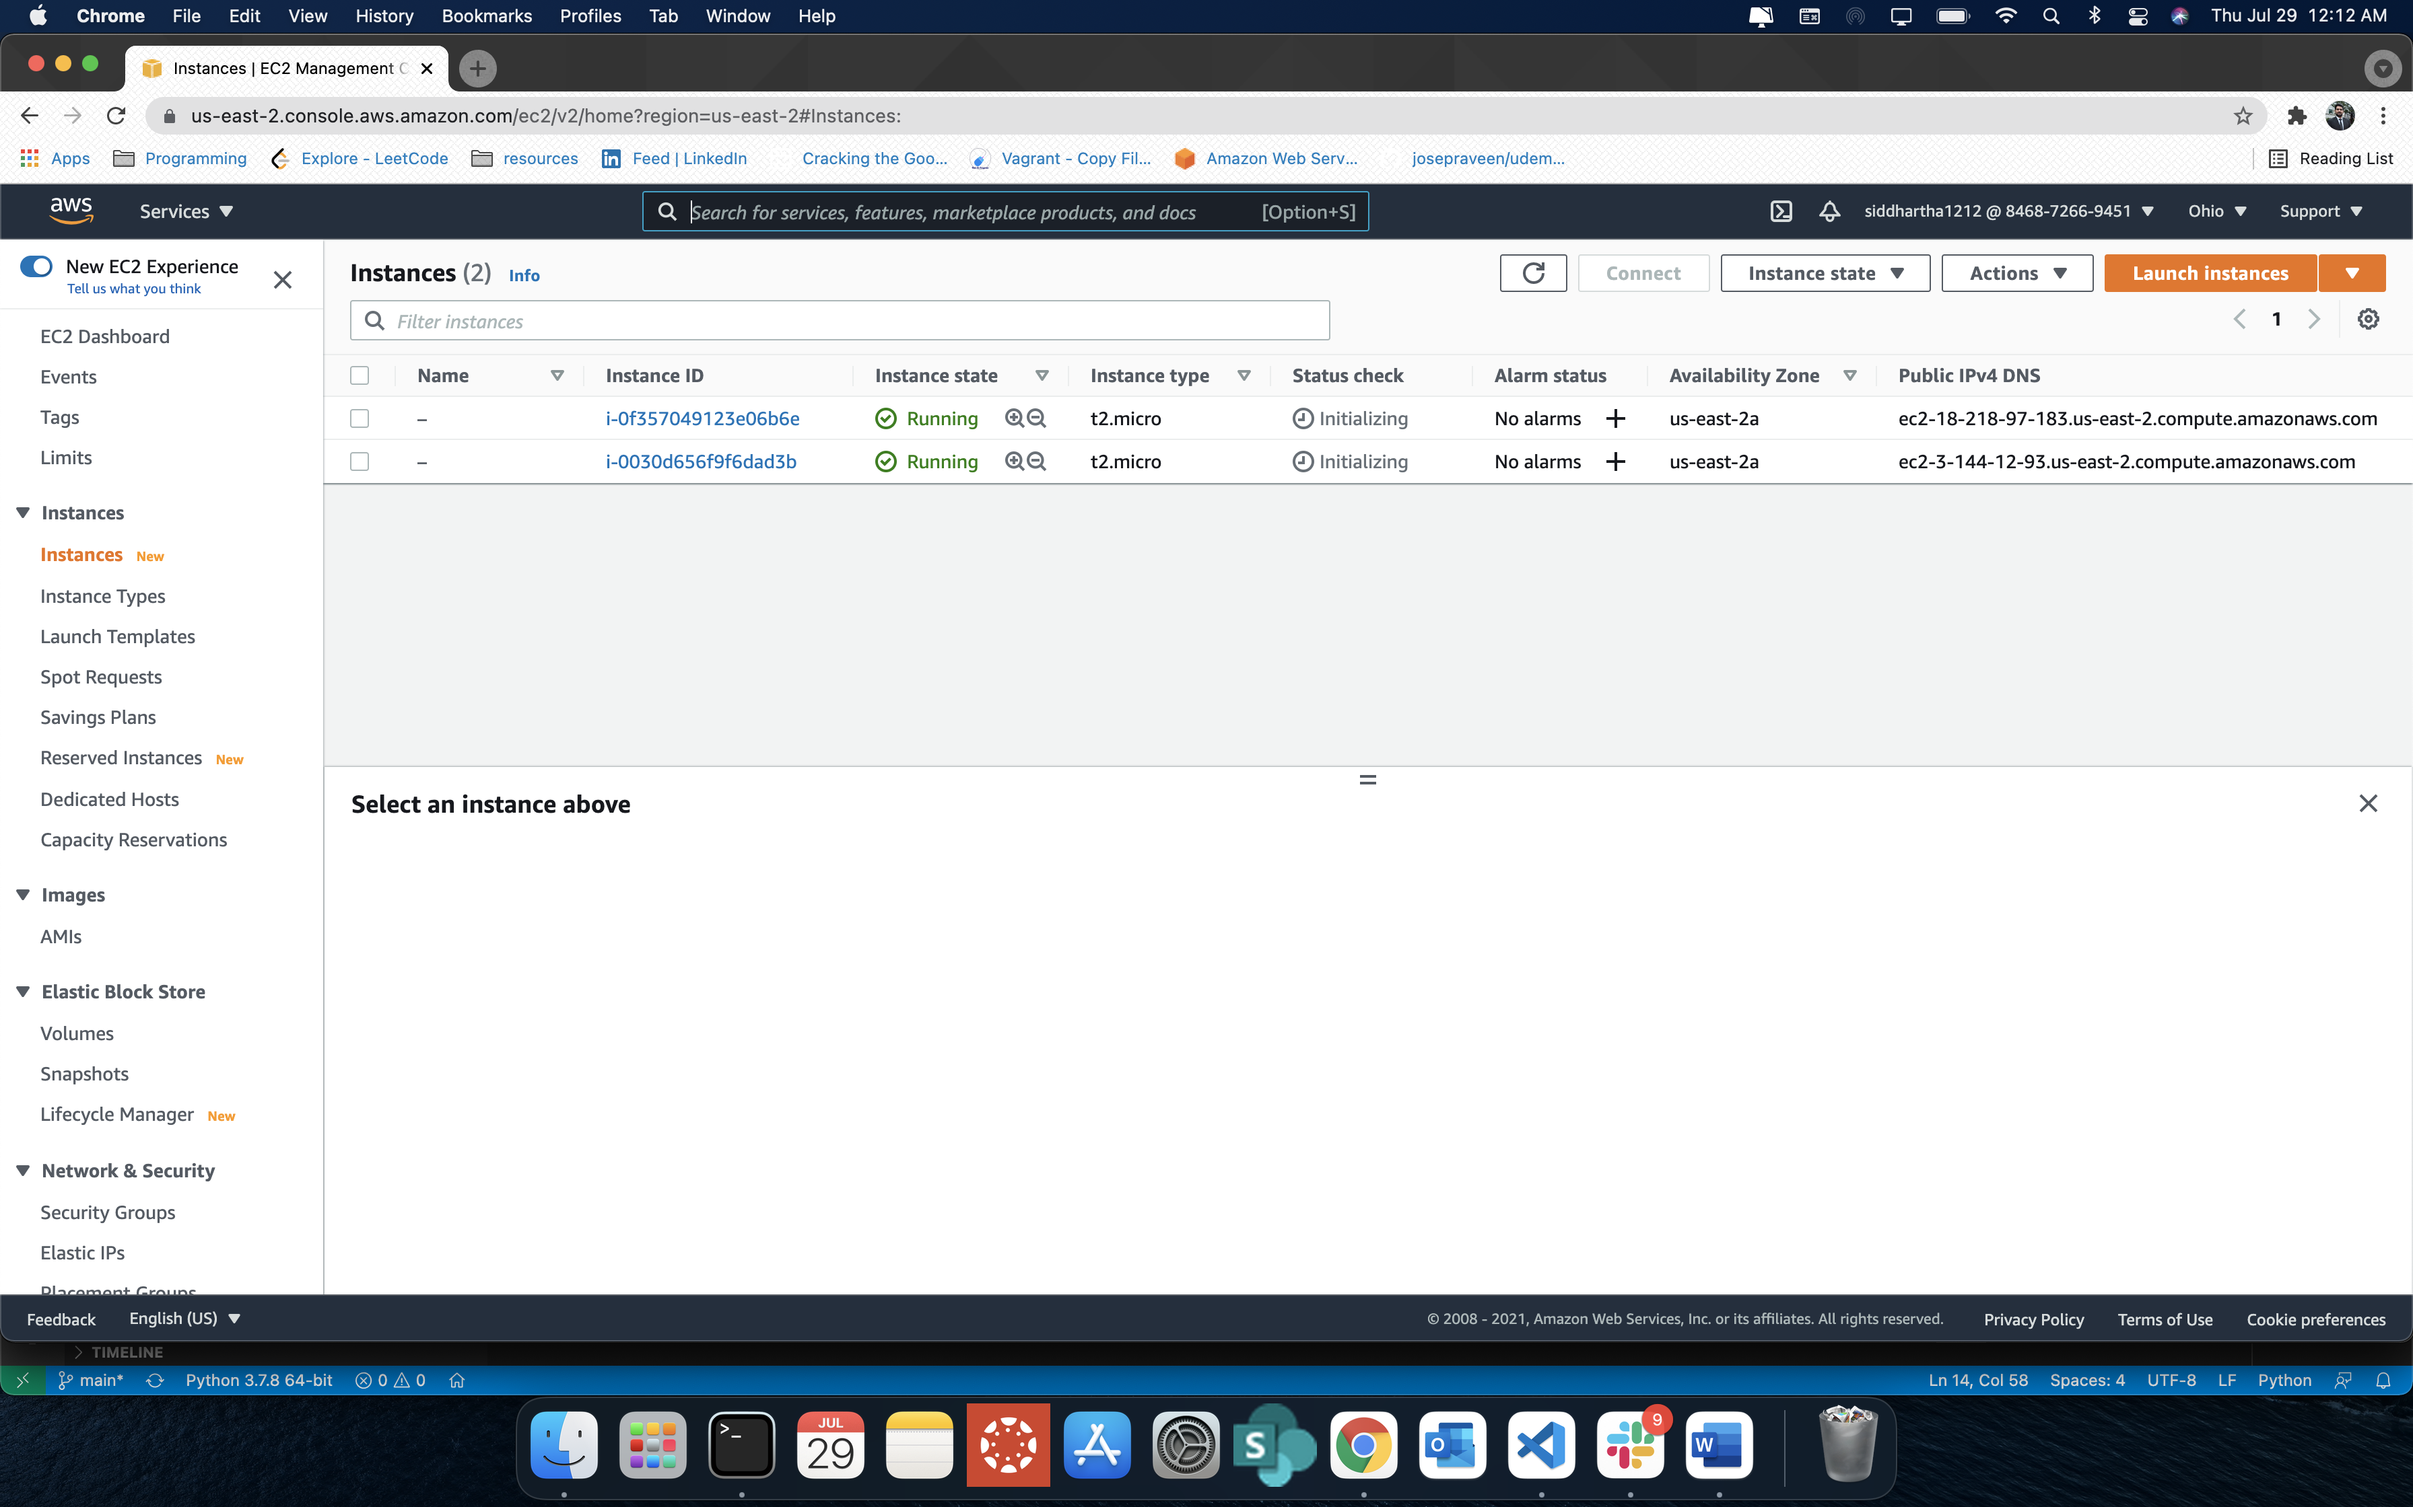

* 1. Instance 1

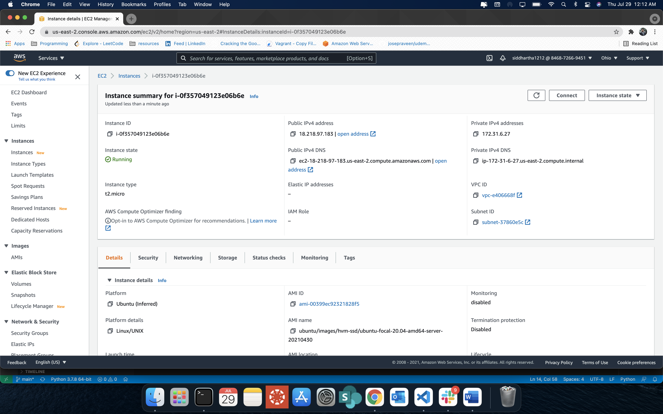

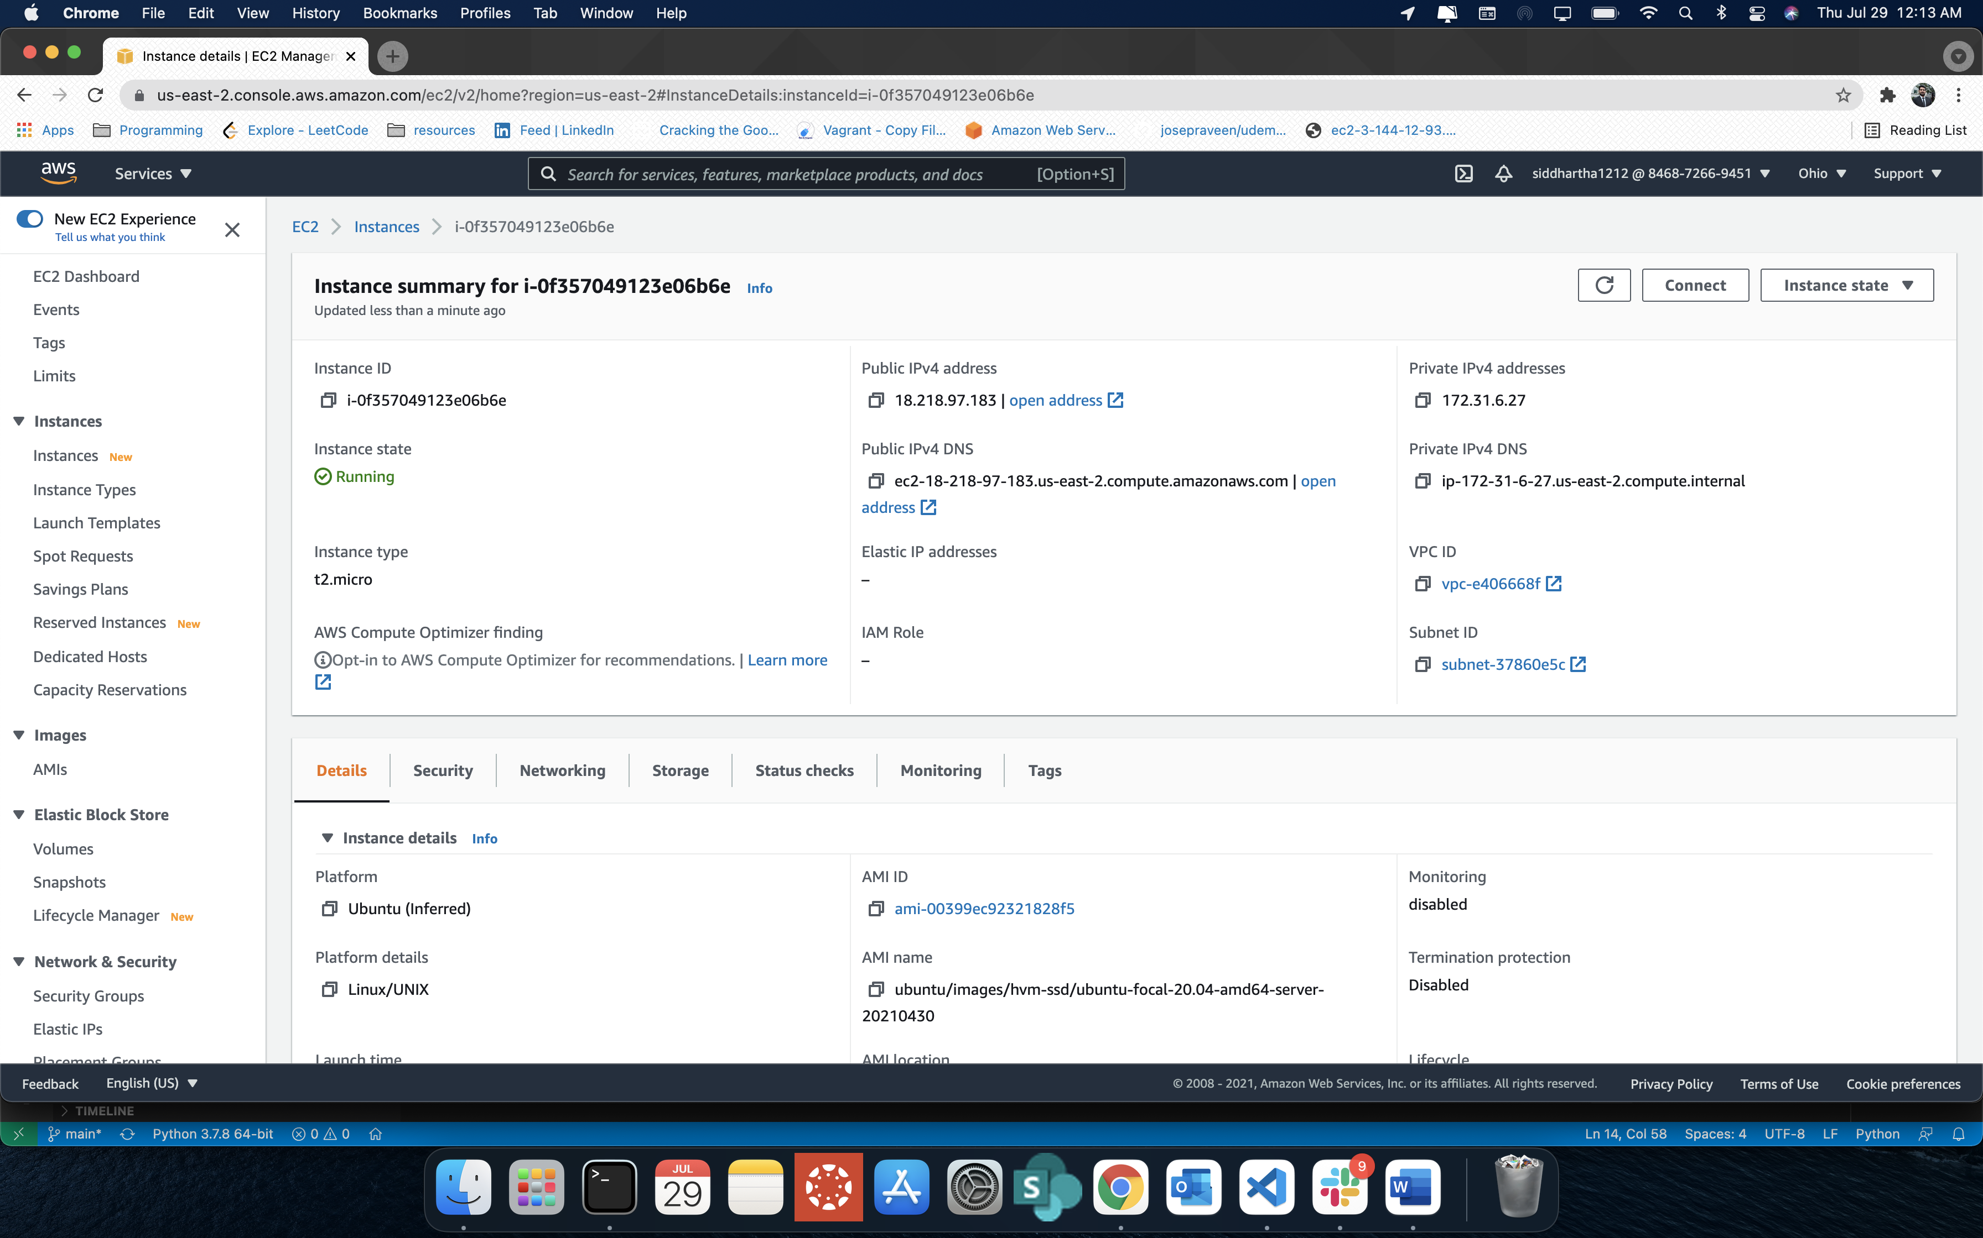

* 1. Instance 2

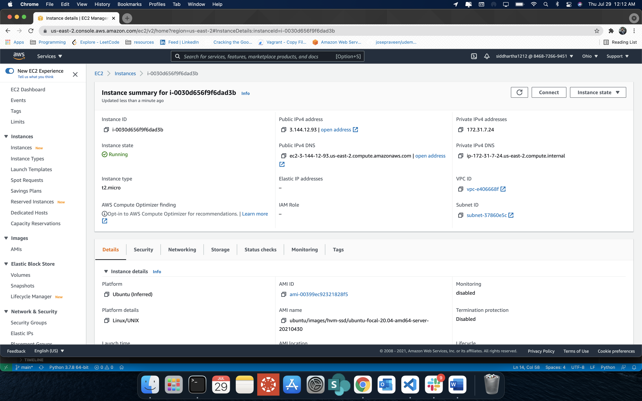

Web page output

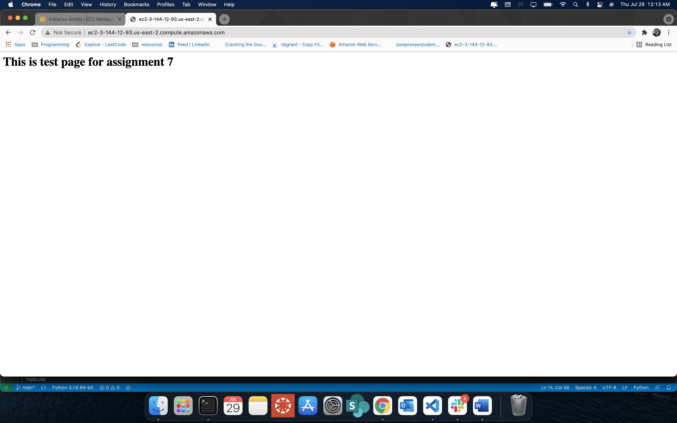

1. After terminating 1 instance

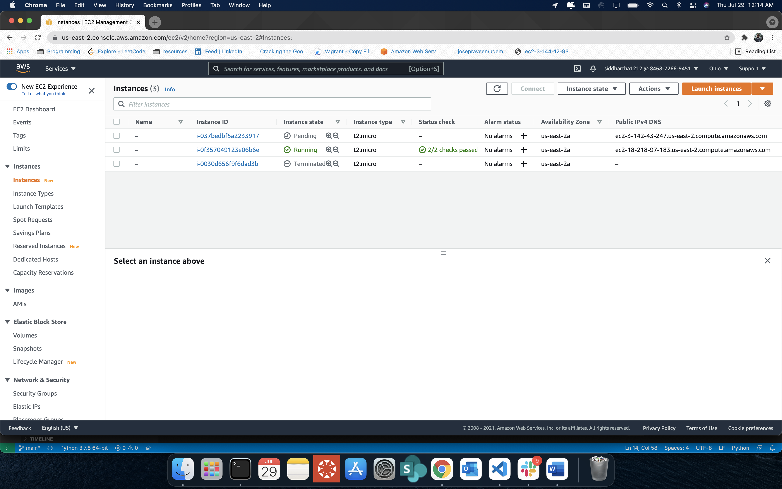

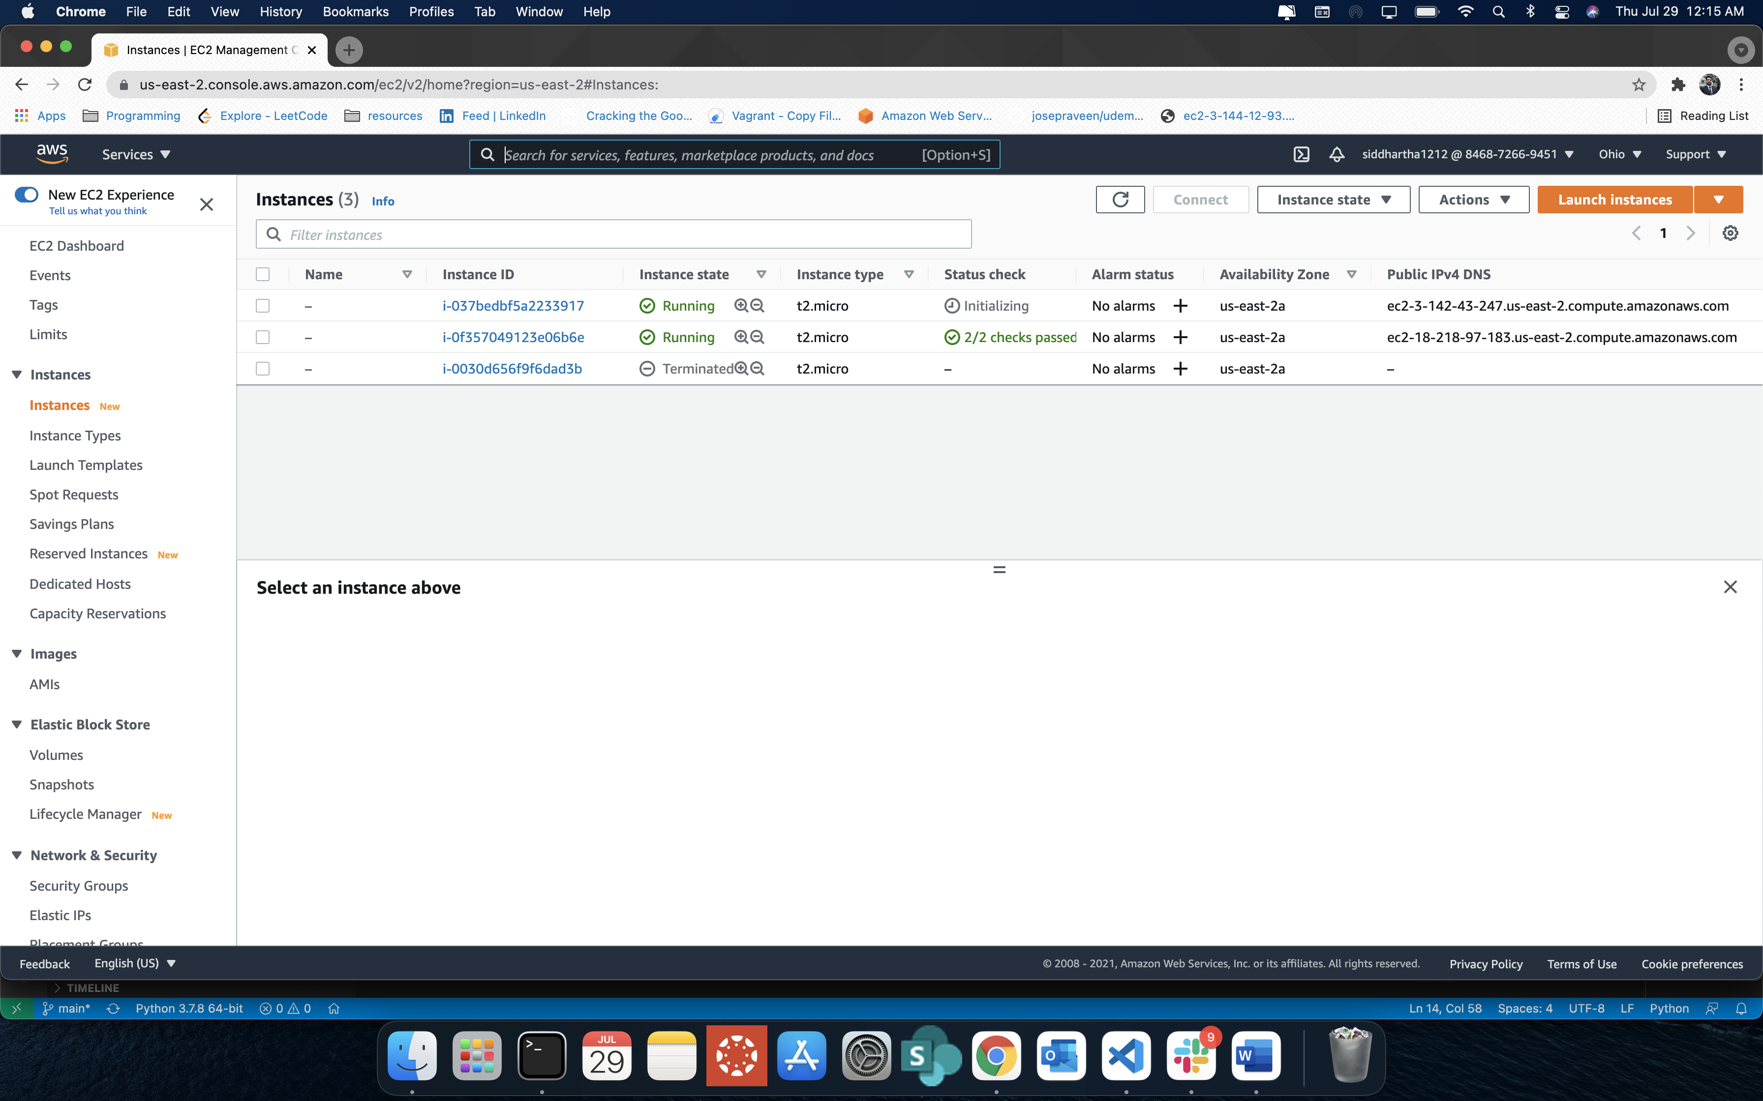

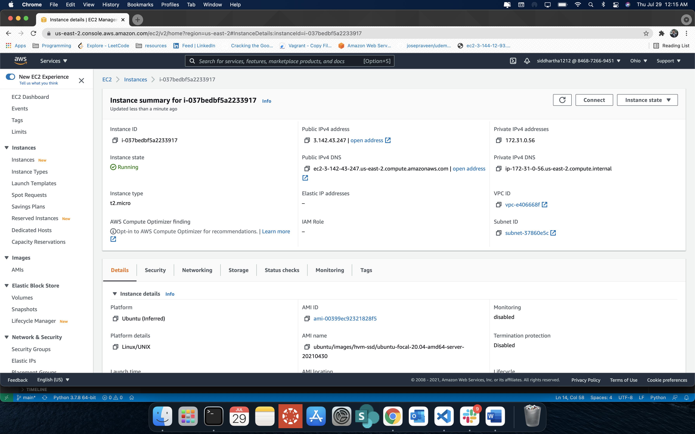

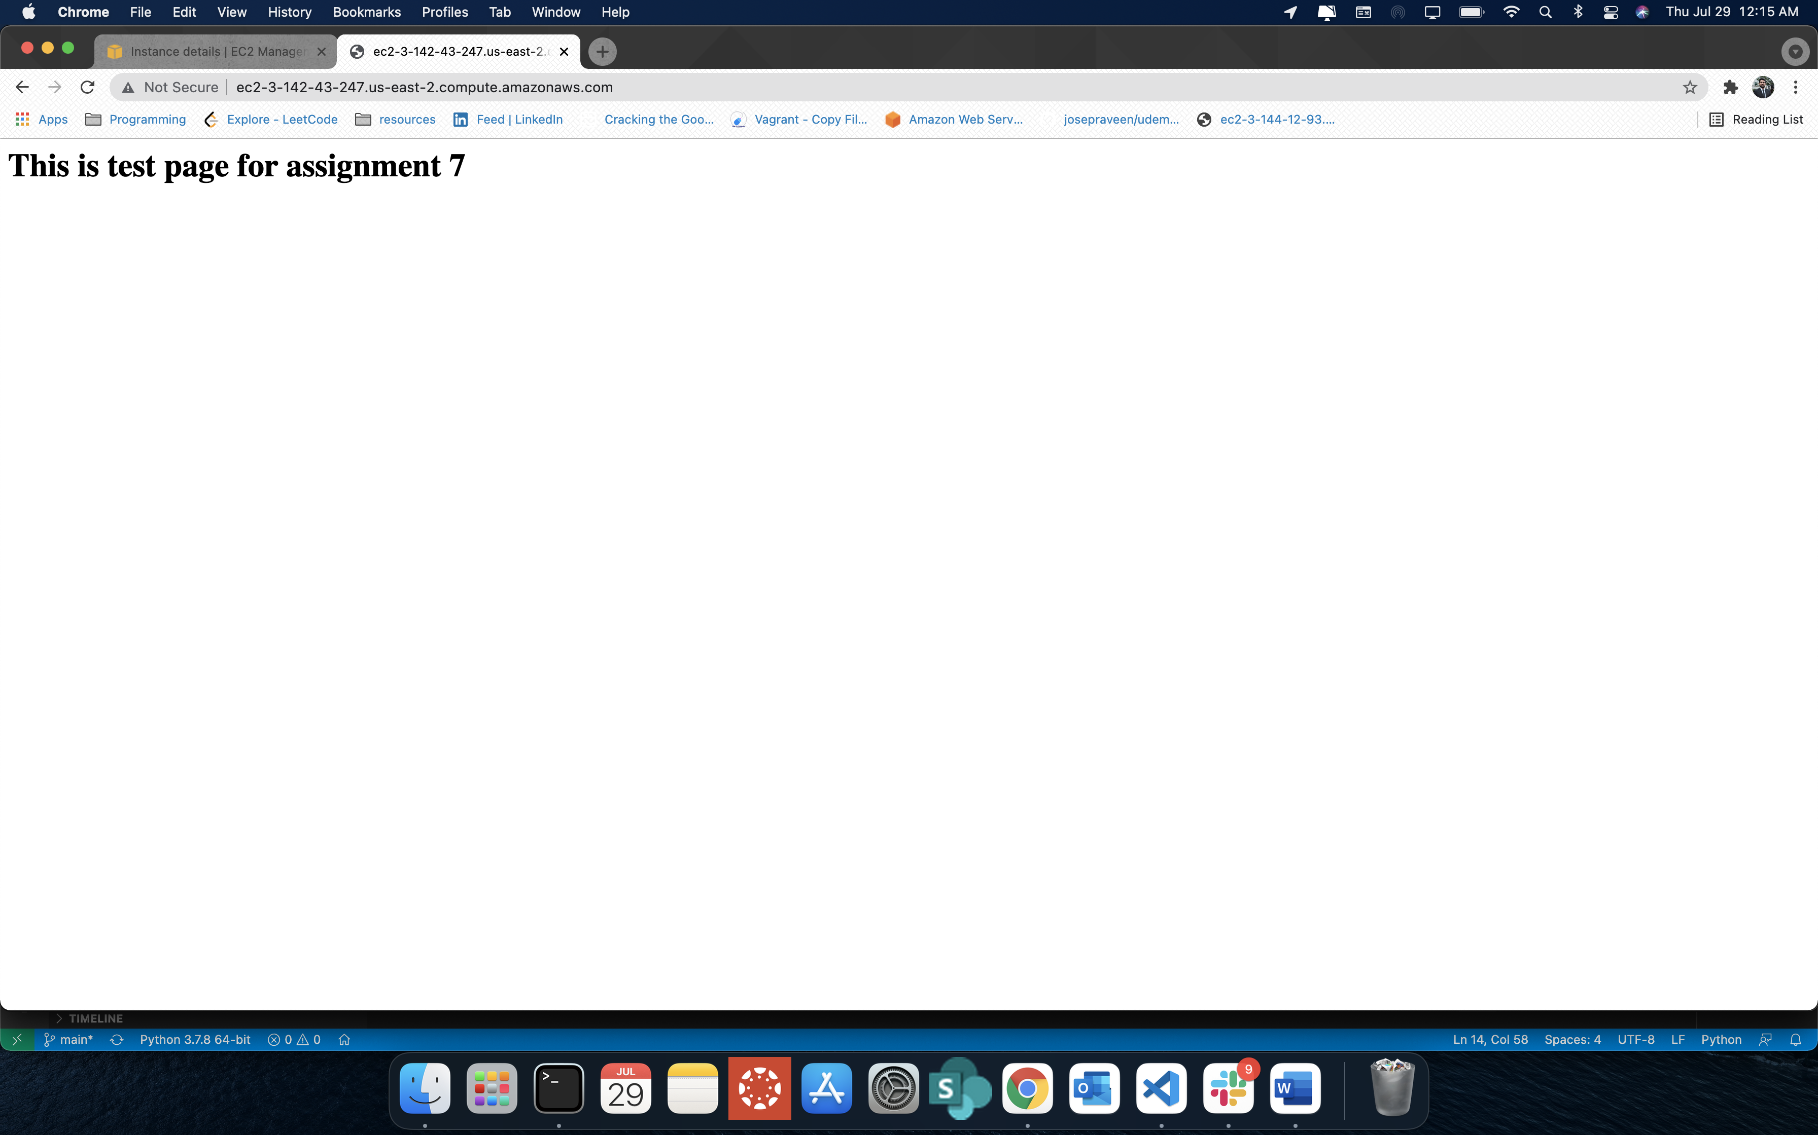

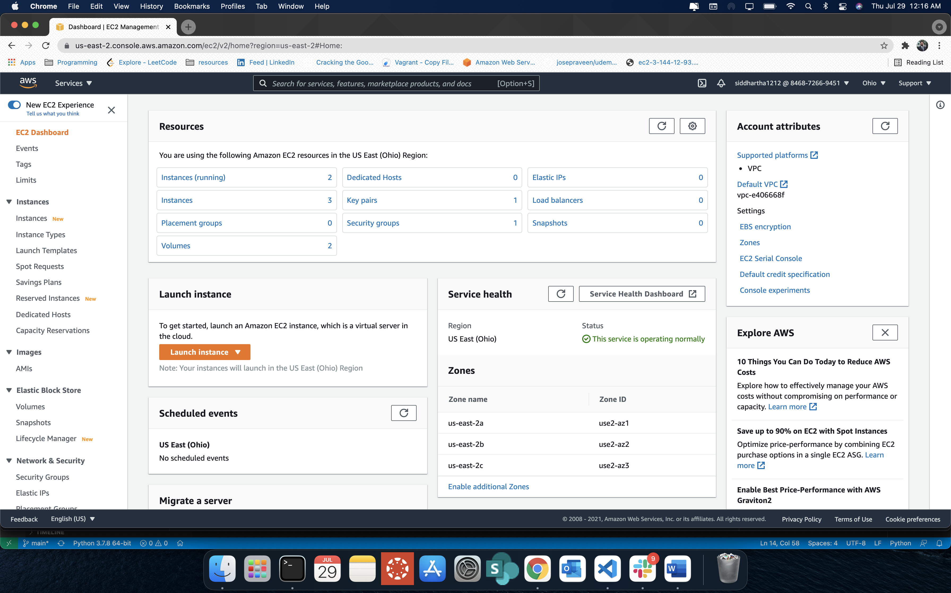

1. Security Group

